Year 2 History Homework Project
In our History lessons, we are going to be learning about…

Significant Individuals

For your homework project, I would like you to bring into school something that you have researched or created about our topic.
The focus will be on these two significant individuals:
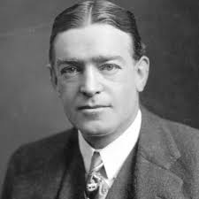
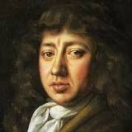
Samuel Pepys
and
Ernest Shackleton

Ideas for your project could be…
- Fact file
- Painting/Drawing
- Diary entry
You can be as creative as you like.

Please bring your projects back when we return to school.
Thank you,
Miss Penny

