Call of the Wild - Diary Entry

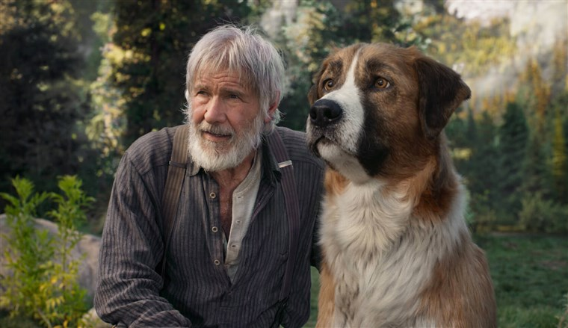

This half term we have been reading The Call of the Wild by Jack London.

Your task is to write a diary entry from the perspective of Buck and this diary entry is from the day Buck met John Thornton.

Think about how John saved Buck’s Life.
What emotions would Buck have felt? He had finally met a human who is kind to him.
Remember to use all your descriptive writing features and to link your paragraphs using cohesion.
Prediction

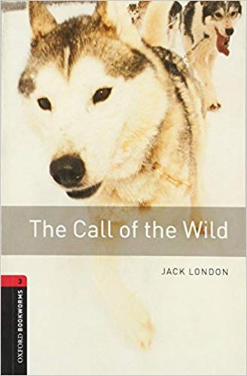
Prediction
How do you think our class text will end? Write a prediction about how you think The Call Of The Wild will end.

You might want to think about…
- Will Buck have an owner?
- Will he return to the judge?
- Will he survive the harsh north?
- Will he stay with John forever?

