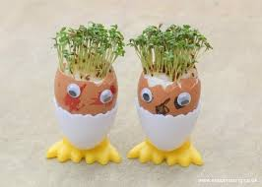 Reception Homework Project

Instructions for growing cress

1. Find a pot or container to

grow your cress in (you can

also use an egg shell).

2. Put the cotton wool into your pot, container or egg shell.

3. Sprinkle the cress seeds onto the cotton wool.

4. Wet the cotton wool and seeds with water.

5. Put your pot, container or egg shell near the window.

5. Water the cress every day and watch it grow!

6. Ask a grown up to cut the cress and wash it.

7. Eat it on its own, in a salad or in an egg sandwich!

As part of our topic on ‘Growing and Lifecycles’, we would like you and your child to grow some cress seeds at home.

As the seeds grow, please can you encourage your child to write daily in the diary provided to record any changes.

We would like you to remind your child to use ‘Fred talk’ (sounding out) when spelling words and to encourage them to write in sentences.

You and your child may also like to measure the height of the cress seeds as they grow which you can do with a ruler, cubes or fingers. It would be great if your child could record this information too! ☺