Name: _________________ Year: ____________

MyOn – Online Reading Books and Quizzes
www.myon.co.uk

 | Username | Password

Purple Mash – Curriculum Work
https://www.purplemash.com/sch/berrybrook

 | Username | Password

Times Table Rock Stars – Times Table Practice
www.ttrockstars.com

 | Username | Password

Purple Mash
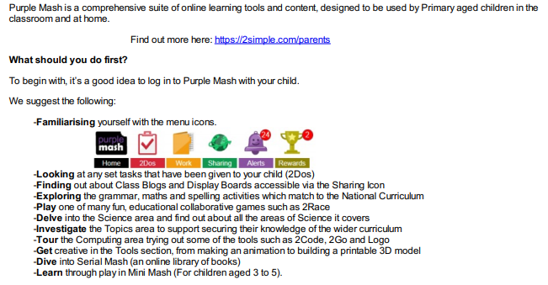

TTRS
Go to https://play.ttrockstars.com/login/33326 and enter their details.
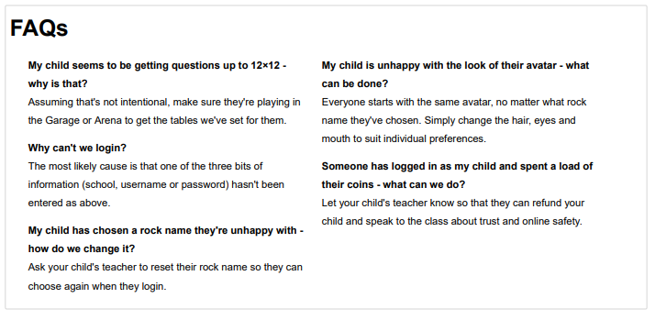

MyOn – Reading
- Ensure that you are on www.myon.co.uk and not .com.
- Search the school name and then type in the username and password provide by school.
- Children should then be able to access books at their reading level.

